AWS CODE-COMMIT
- Github -> VCS -> opensource.
- But for organizations, they don’t use public repositories. Instead they either use private repositories or implement Git solutions (github or gitlab) in their own servers, managed by the org only.
- Code-Commit is AWS managed private git solution. AWS takes care of scalability and reliability.
- NOTE: Code-Commit does not work well with root user, instead use iam user
- Disadvantages:
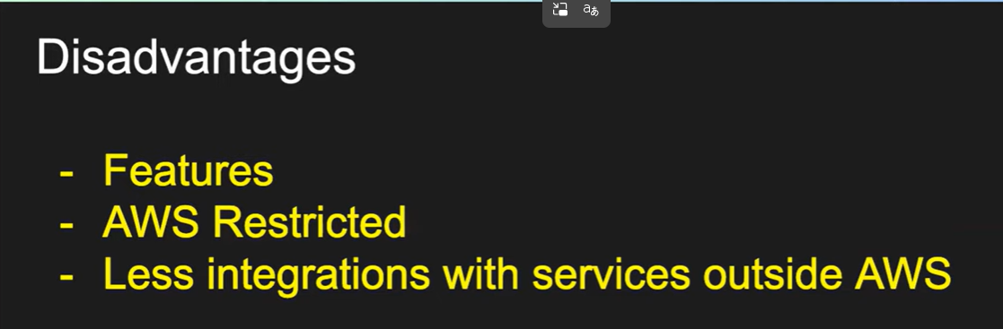

Create a GIT Repository:
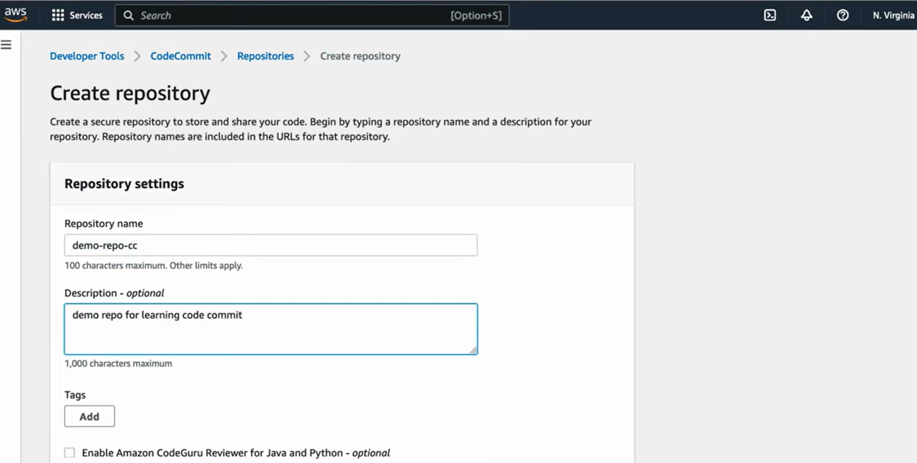

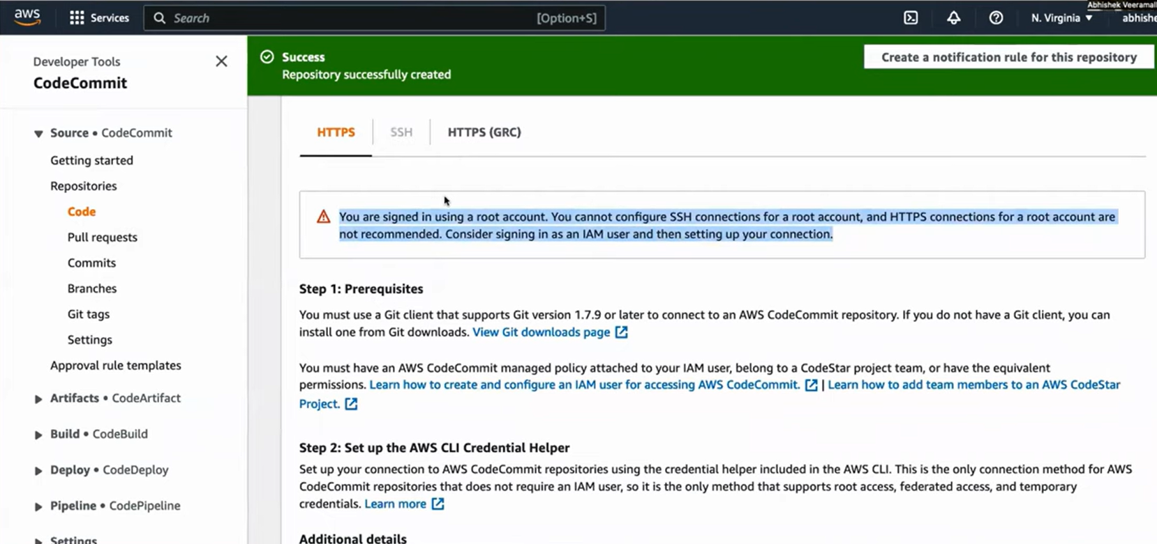
To Upload File in Repo through UI:
- Go to the created repo
- Scroll Down, and Click add file -> Upload File
- Add author name and email -> Commit

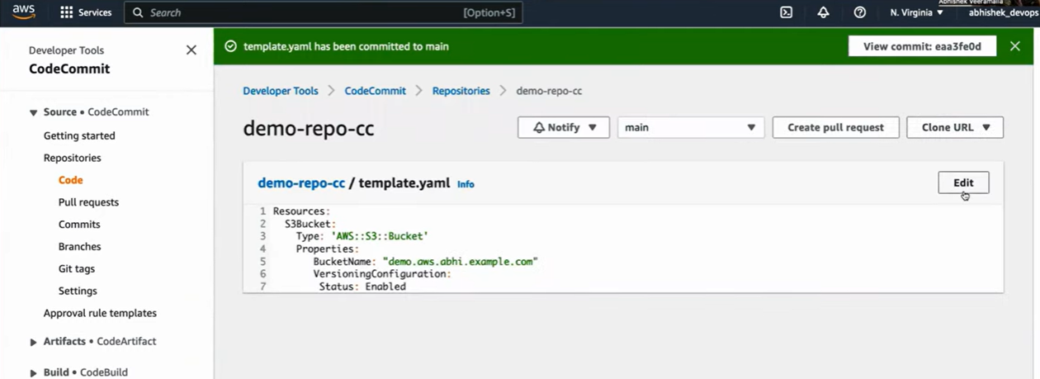
Note: we can upload only one file at once.
Note: We cannot do cloning with root account (using SSH). HTTPS is a secure option, but not recommended.
Create IAM user for Code-Commit:
- IAM -> Create User

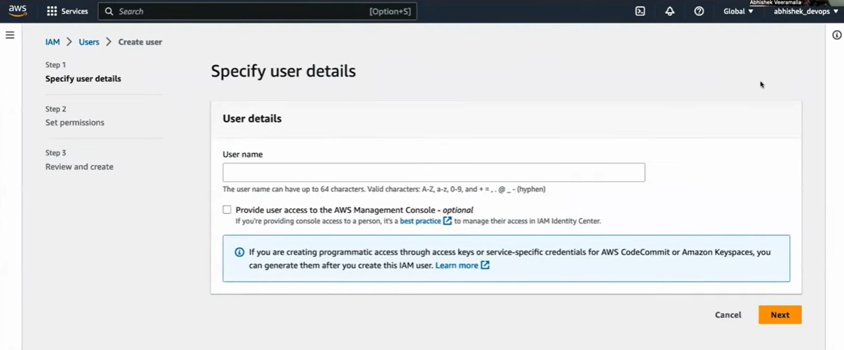
- Provide name, check “Provide user access to the AWS Management console” checkbox,
User type – “I want to create IAM user”, provide custom password & NEXT
- Attach policies directly: AWSCodeCommitPowerUser
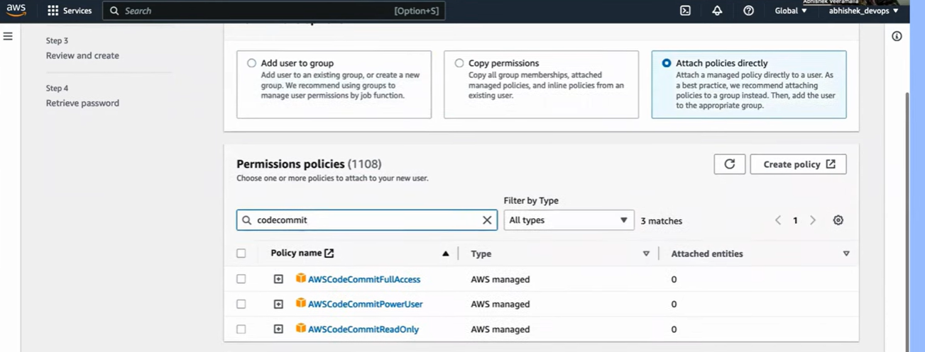
- Next -> create user.
- Go inside the user -> Security Credentials -> Go to “HTTPS Git credentials for AWS Codecommit”
- Generate and download the credentials
Clone the created repo using Terminal:
- Login with IAM user
- Install git in you local terminal
- Go to your repo in code-commit -> Clone URL -> Clone HTTPS
- Go to local terminal -> git clone <copied https link>
- It will ask for username and password
Add code and Commit locally & push to Code-commit:
- Add a file using the terminal
- Check status using $git status, Add - $git add . , commit - $git commit -m “message”
- $git push origin master
- It will ask for username and password
Note: in every step in terminal, like git clone or push, It will ask for password and username. To overcome the same process everytime, use the global credential command once and done!
$ git config - -global credential.helper manager

